sanitation for those with special needs

introduction
For a long time, the Ugandans with special needs have been marginalised. They hardly can access public buildings – offices, places of worship, classrooms and more important, latrines used by people without special need (normal people). Of recent, the Government of Republic of Uganda, together with external support agencies has attempted to help people with special needs live a decent and independent life.
This move has been characterised by a proliferation of programmes and plans to work with people with special needs and “liberate them”. The government has set up rehabilitation centres to fabricate aids, for people with special needs. The special schools for training teachers (Special Needs Education-Kyambogo) have been set up to train teachers and inspectors of schools to effectively handle children with special needs.
Some institutions, mainly primary schools have attempted to admit children with special needs. Classroom entrances have been modified to accommodate the needs of these special needs children.
Latrines in such primary schools have also been slightly modified to ease access of special needs children. But such modifications in most schools involve providing a ramp at the entrance to allow a child in a wheel chair to enter the latrine. Hand rails has been fitted inside the latrine superstructure to enable the children turn and position themselves on the squat hole, dress up and come out without assistance.

Problems with the current designs
- All these modification, although have contributed to encouraging the children with special needs to access the latrines independently, they are not adequate as they do not meet the needs of all types of special needs. Quite often, children are seen crawling in urine/faeces laden floors, as the wheel chairs cannot enter the latrine doors – too small.
- Sometimes, the space inside the superstructure is too small for the wheel chair to turn. It actually blocks the squat hole thus forcing the user to leave it outside and crawl inside.
- The shutters quite often close from inside. This not only reduces space for the wheel chair to turn, but becomes difficult to open and close from wheel chair. Privacy is sometimes compromised. Remember that we all need privacy when visiting latrine!
- There are no other accessories like straps to enable the user manage the clothes before and after defecating.
- The latrines drop holes are mainly squatting-hole types and not friendly to those with squatting difficulties.
- There are normally no hand washing facilities. If they exist, they are either empty or no detergent is provided. Children who have crawled in excreta-laden floors are likely to be discouraged from using the latrine.
- The latrines are not normally cleaned in time. The special needs children while willing to participate in cleaning them may be discourage by the schoolteachers who may stop them from participating.

How to effectively provide sanitation for people with special needs
Identify and analyse the categories of people with special needs. There are four categories of people with special needs.
- Hearing impairment,
- Visual impairment,
- Mental retardation,
- Physically handicapped,
The sanitation technologies are designed to suit the special needs of these categories.

Sanitation for people with hearing impairment
People with hearing impairment have no major constraint in using latrine and other sanitation facilities. They often have no serious difficulties in accessing latrines. They use sign language to learn how to use latrines and/or seek permission to use the latrine.
They use latrines use latrines used by normal people.

Sanitation for people with Visual impairment
People with visual impairment largely rely on other senses to live and be able to live conformably with others. Quite often, they rely on the sense of feeling/touching to differentiate objects and facilities. Hearing is also very important for them. They quickly learn to differentiate different sounds to mean different objects.
Latrine facilities for people with visual impairment must be designed in such way to enable them access and utilise them without having to rely on helping hands.
They can use latrines with the following modifications.
- Ramp. To ease access, the latrine entrance should have a ramp not steps.
- “Land marks to latrine”. The location and the inside of the superstructure should have what I wish to call “land marks”. These are physically distinct objects deliberately positioned to guide the visually impaired person to reach and use a latrine without assistance from another person. These can be used car tyres strategically positioned from the main house/classroom/institution up to the latrine entrance. The visually impaired person can then use the “white cane” to count the number of these tyres and be able to know that s/he has reached the latrine entrance. The number of these landmarks must not be varied. Training is critical to enable the person utilise the latrine independently.
- “Land marks within the latrine”. There are “Land marks within the latrine” to guide collect position on the drop hole. These can be knots tied on a string. The people will touch and count them up to the last that indicate to him/her that the drop hole is within reach.
- The door should open inside to ease closing while near the drop hole. If it opens outside, the person may have spend time “looking for it”.
- The anal cleansing materials should be position in a corner known to the persons with visual impairment. No changes in positioning these materials should be made without prior discussion and agreement with the users. Sudden changing may create confusion.
- Hand washing facilities should also be labelled with landmarks to guide collect utilisation. The tap handle should have an elongated piece to ease opening and closing. The path form the hand washing facility to latrine and classroom/main house should also be labelled with landmarks to ensure that the user is self-reliant.

sanitation for Mentally retarded people
The degree of severity can be severe, moderate or mild. The degree of severity influences the ability of the individual to learn and utilise sanitation facilities independently.
Mental retardation may affect bowl and bladder control and/or awareness.
Special aids are required.
- Children with cerebral palsy. Cerebral palsy children are usually slow in developing bowl and bladder control and awareness. Training in how to use sanitation facilities independently may take long. The condition however improves with age. Waiting until child is older can help. In the mean time, a special potty seat can do since such children need to sit. It acts both as a seat and potty. It must be cleaned promptly and the excreta put in the latrine or buried.
- For the child severely disabled with cerebral palsy. The pottie can be placed between mother’s knees. This provides good back support. Mother holds the baby’s shoulders forward, bending its hips and separating knees.
- If child has trouble pulling down pants. Use loose fitting clothing with elastic or ‘velcro’ waistband. ‘velcro’ is a self-adhesive plastic tape, where tiny hooks on one surface catch on loops of the other.
- Correct positioning of hands for lowering of pants. Train the child how to hook thumbs inside pants and push down. For raising of pants, train child how to put hand inside pants to pull over butt. Use safety pin to pin shirt up out of the way.
- Training in self-reliance is critical. Patience on the part of the trainer is a pre-requisite to effective training.

Sanitation for Physical handicapped
The most common sanitation facilities in Uganda are those for people who are physically handicapped. The latrines are made for squatting over rather than for sitting on. Basically, they consist of a hole in the floor.
For children and old people who are physically disabled and who use wheel chairs or children with balance or movement difficulties, the latrine should be designed to have the following components:

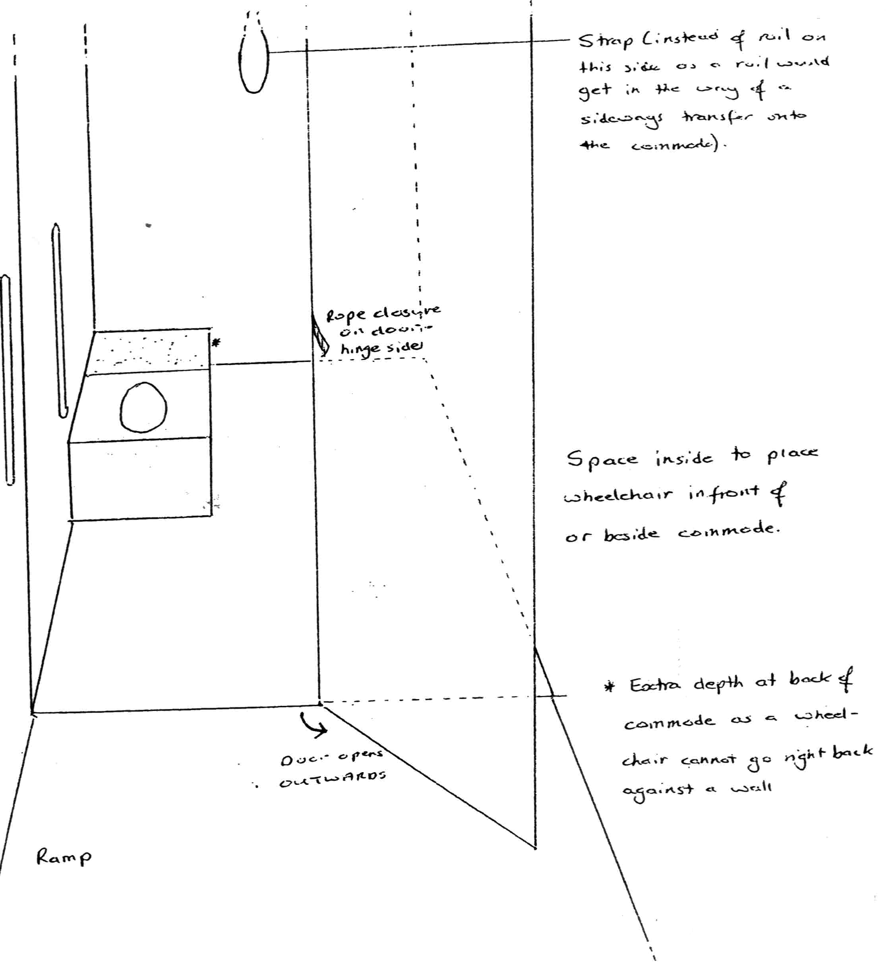Diagram 1: An illustration of some components of latrine for special needs people
- A ramp in not a step at the latrine entrance. This eases access to the latrine on a wheel chair.
- The outwards opening door shutter to “create” more space inside the latrine for the wheel chair. The door should have a rail outside to help when opening,
- The rail inside the door to enable it to be pulled closed when in a wheel chair,
- A facility known as “Commode” with drop-hole to ease the sitting when defecating,
- Space in front of the commode to ease turning around to sit on the commode,
- Space at the side of the commode to ease sliding onto to the commode,
- Space inside to place wheel chair in front or beside commode,
- Extra space at the back of the commode to enable the wheelchair to turn with ease. Wheel chair can be blocked by the wall,
- Strap instead of rail on top behind the commode as the rail would get in the way of side ways transfer onto the commode,
- Horizontal rails at about 17cm above seat,
- Vertical rails at 8cm from the wall, to help while managing clothing
- Rope inside the hinge of the door fastening besides the rail to enable the person in a wheel chair to be able to reach and close the door

examples of sanitation for special needs people around the world

ralf hotchkiss whirlwind
Ralf Hotchkiss (David Werner [1998]) whose spinal-cord injuries could not allow him transfer to latrines or other facilities without first falling down.
- To get back into his wheel chair from the ground in these circumstances, Ralf designed a small cloth step or jump seat → transfer seat, half way between his wheel chair seat and the ground.
- This way, he can first lift himself onto the lower-level seat and from there, into the wheel chair seat. The front edge of the jump seat also functions as an ankle-band to keep his feet from slipping backward off the footrests.
- Ralf had difficulties in using pit latrines. He cut a round hole in the jump seat of his wheel chair and perch on that. He revised the design of the jump seat and toilet seat to include a flap that kept in place for the transfers and is folded up out of the way for toileting or bathing.
The flap fastens into place with Velcro tabs. In Uganda, if the self-adhesive Velcro tabs are not available or are expensive, then ordinary buttons can be used.

Trolley and wheel chair latrines
- In some countries like Bangladesh low-riding trolleys are often used instead of wheel chairs because people traditionally eat and cook at ground level. The trolley rider sits on a soft coconut-fiber mat on top of an air-filled inner tube from a motorcycle.
- The inner tube functions both as a cushion and as a toilet seat. Centred under the hole, in the tube, a small removable aluminium removable pot fits into the metal frame of the trolley.
- To convert the tube into a latrine seat, the person just removes the mat.
- For travel on crowed public buses, the trolley is collapsible. The back folds down. The projecting leg-rest slides in.

Hand washing facility for those with special needs

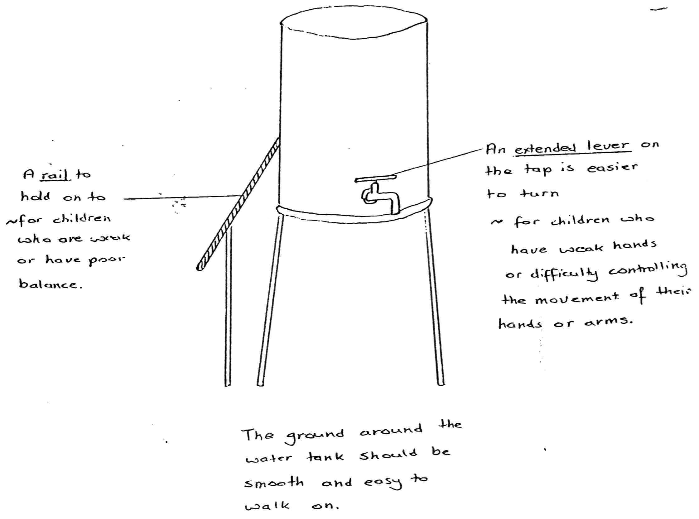
Diagram 2: An illustration of hand washing facility for special needs people

- Should have a rail to hold onto for people who are weak lower limbs or have poor balance,
- The ground around the water tank should be smooth and easy to walk on,
- An extended lever on the tap to make it easier to turn

Conclusion
In Uganda, we are slowly progressing towards developing sanitation technologies for people with special needs. While attempts have been made to enable these category of people to independently manage their excreta, the main efforts appear to focus on helping only those with physical handicap. There is therefore need to look beyond this narrow thinking to helping those with other special needs.

Adopted from David Werner (1998), Nothing About Us Without Us: Developing Innovative Technologies For, by and with Disabled persons

