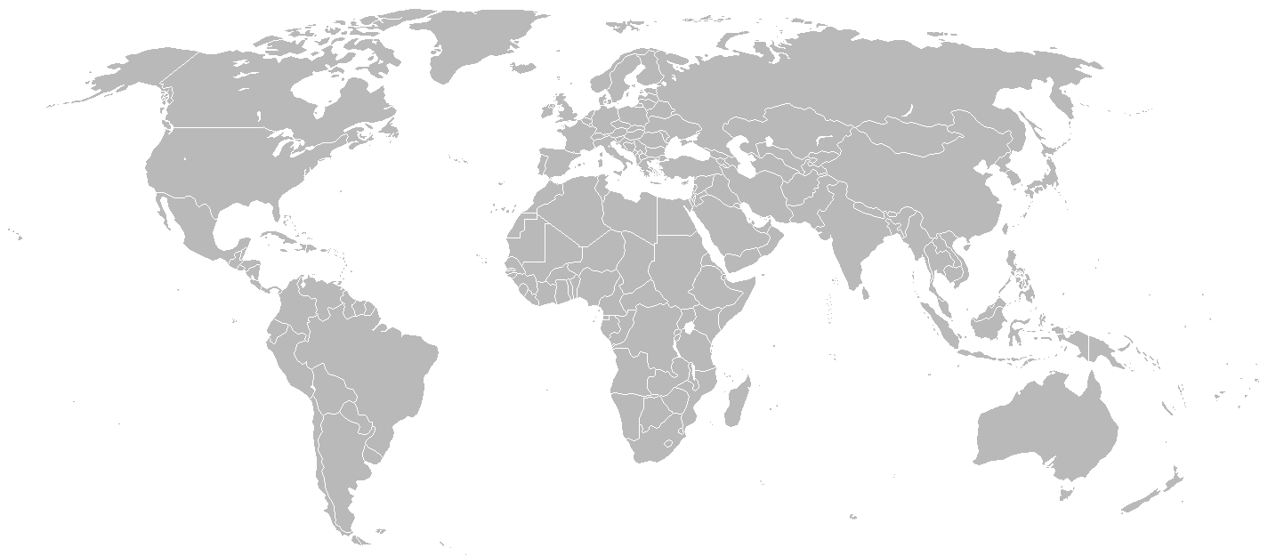
Fig. 1: Project location (location will be added by GIZ ecosan team)

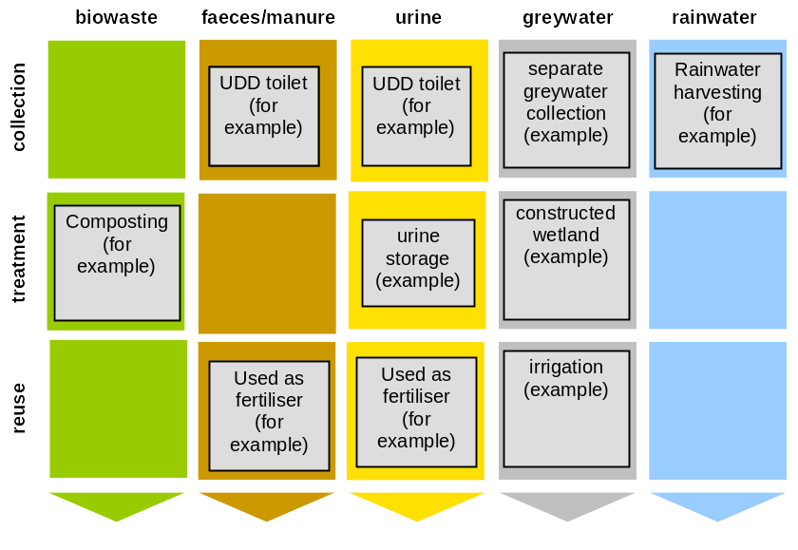
Fig. 2: Applied sanitation components in this project (double click on the graphic to edit it)

Type of project:
(e.g. rural / urban upgrading or new constructed area,
individual or community-based sanitation,
pilot scale or full-scale)
Project period:
Start of construction: month/year
End of construction: month/year
Start of operation: month/year
Ongoing monitoring period planned for: xxx
Project end: (if there is a planned end date)
Project scale:
Number of people covered:
Number of toilets (if applicable) or size of treatment plant
Total investment (in EUR)
Address of project location:
(Address)
Planning institution:
(Name of institution and location)
Executing institution:
(Name of institution and location)
Supporting agency:
(Name of institution and location)

Note: the length of this document should ideally be about 6 pages (range: 4-8 pages).

Please use British English spelling (use s instead of z).

Please do not use symbols for currencies. Please give cost figures in EUR.
Description of main motivation (driver) and objectives of the sustainable sanitation project.
Description of the location and its general conditions, with emphasis on conditions relevant to the implementation of the sustainable sanitation project, such as:
- climate and geographical conditions
- population density
- type of settlement
- general water and sanitation situation
- economic situation
- agricultural aspects, type of soil
- institutional and legal framework
- socio-cultural conditions

Fig. 3: A representative photo of the project should go on the first page (source: xxx; also the year in which the photo was taken)

- health aspects: under 5 child mortality

Example text (keep the following footnote and find actual child mortality on that website):
In Kenya, the under-five child mortality rate is currently 128 children per 1000, and sadly there has been a slight but consistent upward trend towards more child deaths since about 1985 when the value was 98 child deaths per thousand.
Starting point and milestones of the project, specific hindrance and favouring aspects. Also projected future milestones can be described here.
Description of applied technologies and implemented infrastructure with emphasis on collection and treatment facilities, application requirements, transportation distances, and justification of technologies (why the technologies have been chosen). Also: how were future users involved in the process.
Design information that has been used in planning for the project:
- basic design parameters
- assumptions
- applied design and construction methods
- construction materials used
- plans and drawings (if available)

Description of the type and level of reuse applied in the project and organisational scheme for the collection-treatment-reuse chain:
- application of sanitation-based fertiliser
- frequency of application
- crops planted and plant requirements
- observed changes in yield
- area under cultivation

If no reuse (or only limited reuse) is practised, then a short statement on why this is the case would be helpful.
Further components of the project (in addition to sustainable sanitation components described above), e.g. solid waste management, additional research on social and economic issues, up-scaling activities, etc.
Details on investment, operation and maintenance costs and subsidies involved (if any). Description of the financing scheme for the collection-treatment-reuse chain.

Ideally: a cost break-down table for the capital cost and for the operational costs.

Please give all costs in the currency EUR (do not use the currency symbol), so that they can more easily be compared than if they were given in local currency.
Please give information on the management model used to keep the project running, i.e.:
- responsibilities for operation and maintenance
- collection of tariffs

Also describe how the maintenance is carried out and by whom (consider also gender issues). Describe aspects regarding use of the system (how is it used?).
Description of experiences (acceptance of technologies, technical aspects, scale of impact on the stakeholders involved, gender issues, mistakes made, lessons learnt, etc. Also include analysis of occurred problems, challenges, constraints and recommendations for future activities.

Remember if any mistakes were made, these are the best lessons for others to avoid making the same mistakes. So it is interesting to hear about all the good and bad things with the project.
Keep this first paragraph as standard text:
A basic assessment (Table 1) was carried out to indicate in which of the five sustainability criteria for sanitation (according to the SuSanA Vision Document 1) this project has its strengths and which aspects were not emphasised (weaknesses).

Please try to fill out Table 1 accordingly (this is not a scientific exercise, but just a very rough and basic indication).

Table 1: Qualitative indication of sustainability of system. A cross in the respective column shows assessment of the relative sustainability of project (+ means: strong point of project; o means: average strength for this aspect and – means: no emphasis on this aspect for this project).
 | collection and transport |  |  | treatment |  |  | transport and  reuse
Sustainability criteria: | + | o | - | + | o | - | + | o | -
- health and  hygiene |  | X |  |  | X |  |  | X
- environmental and natural resources |  |  | X |  | X |  |  |  | X
- technology and operation |  | X |  | X |  |  |  | X
- finance and economics | X |  |  |  | X |  | X
- socio-cultural and institutional |  | X |  |  | X |  |  | X

Sustainability criteria for sanitation:
Health and hygiene include the risk of exposure to pathogens and hazardous substances and improvement of livelihood achieved by the application of a certain sanitation system.
Environment and natural resources involve the resources needed in the project as well as the degree of recycling and reuse practiced and the effects of these.
Technology and operation relate to the functionality and ease of constructing, operating and monitoring the entire system as well as its robustness and adaptability to existing systems.
Financial and economic issues include the capacity of households and communities to cover the costs for sanitation as well as the benefit, such as from fertiliser and the external impact on the economy.
Socio-cultural and institutional aspects refer to the socio-cultural acceptance and appropriateness of the system, perceptions, gender issues and compliance with legal and institutional frameworks.
For details on these criteria, please see www.susana.org: the SuSanA Vision document "Towards more sustainable solutions" (www.susana.org).

Please also write also a paragraph here summarising again what the expected and measured long-term impacts (or effects/results) of the project are/were.

Example text:
With regards to long-term impacts of the project, the main expected impact of the project is improved public health (e.g. reduced rate of diarrhoea incidences in children). It is planned to assess this at the end of the project in late 2012.

Provide here the information on relevant documents (all with website address or e-mail address on how to get them (if not available via website)), e.g.:
- project documents (feasibility studies, design reports, factsheets, bidding documents, operation manuals, training material, publications, maps)
- documents relevant to water sector in the project area
- relevant MSc theses (if available)
- link to photo sets in flickr (if you like: use GIZ flickr photo database to display your photos).
- link to videos (e.g. on SuSanA Youtube account)

Important documents should be uploaded to the SuSanA library! Please send them to info@susana.org
Contact details of all parties involved in the project, including description of role and responsibility within the project (including e-mail addresses and websites of organisations).

Case study of SuSanA projects
Project name (repeat from header)
SuSanA 2011
Authors: xxx (with affiliation and e-mail address)
Editing and reviewing: xxx (with affiliation and e-mail address)

© Sustainable Sanitation Alliance
All SuSanA materials are freely available following the open-source concept for capacity development and non-profit use, so long as proper acknowledgement of the source is made when used. Users should always give credit in citations to the original author, source and copyright holder.

This document is available from:

www.susana.org

The under-five mortality rate is the probability (expressed as a rate per 1,000 live births) of a child born in a specified year dying before reaching the age of five if subject to current age-specific mortality rates (http://www.childinfo.org/mortality.html and http://www.childmortality.org/).

