**DOCUMENTATION OF BEST PRACTICES IN KUNNUKARA PANCHAYATH DURING COVID 19 SITUATIONS**

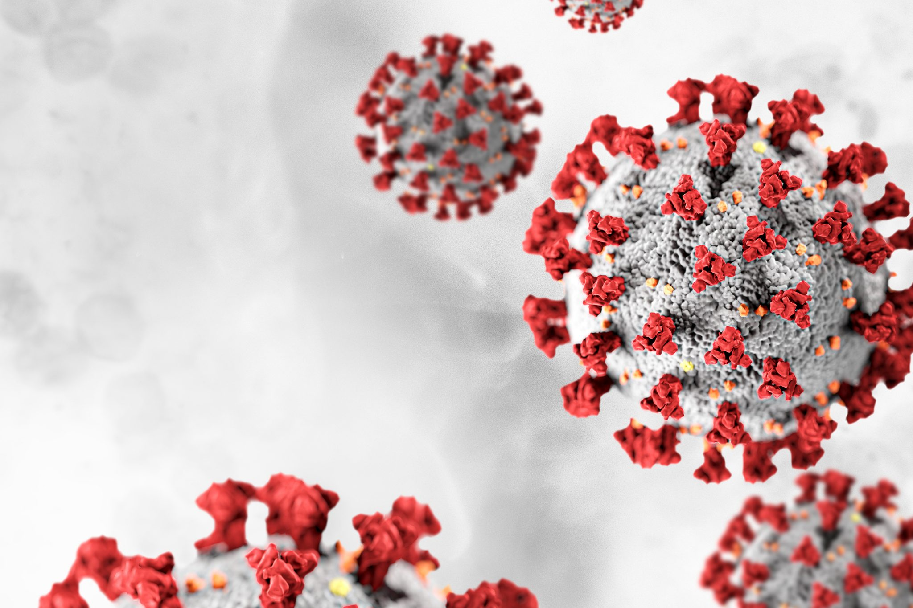



**SOCIO ECONOMIC UNIT FOUNDATION**

JAKRA-43, T.C826/4, V.J.Lane,

Vellayambalam, Sasthamangalam, Trivandrum, Kerala, India 695010

Contents

**COVID-19** 3

**KERALA MODEL** 3

**KUNNUKARA PANCHAYATH** 4

**SKOCH SILVER AWARD FOR BEST CIVILIAN** 5

**1.** **HEALTH CARE ACTIVITIES** 6

**2.** **BREAK THE CHAIN ACTIVITIES** 7

**3. COMMUNITY- BASED APPROACH** 8

**3.1 KUNNUKARA CDS** 8

**3.2 COMMUNITY KITCHENS** 8

**4.** **MOBILE APPLICATION FOR KUNNUKARA GRAMA PANCHAYAT** 10

**5.** **PREPARATION OF QUARANTINE FACILITIES** 11

**6.** **SUBHIKSHAKERALAM** 12

**7.** **MANAGING MIGRANT WORKERS (GUEST LABOURS)** 12

# **COVID-19**

The coronavirus disease (Covid-19) was declared a public health emergency of international concern on 30th January by World Health Organization (WHO) caused by novel severe acute respiratory syndrome coronavirus 2 (SARSCoV-2). In the fight against Covid-19 medical and public health workers are at the frontline focusing on the cure, prevention, and contact tracing.

In India, the disease was first detected on 30 January 2020 in Kerala in a student who returned from Wuhan. The Health Ministry of India has categorized districts into three zones (Ministry of Home Affairs 2020), namely, red (highest risk), green (low risk), and orange (moderate) zones, to identify hot spots and allocate strategies accordingly. This categorization is based solely on the number of cases and does not account for socio-demographic, health status, and hygiene and sanitation components of the vulnerability.

The Covid-19 crisis is largely portrayed as a medical emergency, focusing response on isolation and treatment of possibly and infected persons, as well as stemming further virus dispersal through means of containment and social distancing. In the current rush to contain virus spreading and to treat an exponentially growing number of affected persons, it is largely missed to attribute due value of measures to mitigate potential of the virus to attain persons, hence, to look into appropriate ways and means for effective preventive measures, such as health-conscious personal hygiene routines and disinfection of presumed points and vectors of contamination. Once such considerations are taken into account, automatically the intrinsic connection between water, sanitation, hygiene (WASH) and health, in all aspects of preventive health-relevant behaviour, inoculation of resilience- relevant habits and effective treatment/containment of harmful incidents like the Covid-19 outbreak becomes very evident.

# **KERALA MODEL**

The first case of the COVID-19 pandemic in Kerala was confirmed in Thrissur on 30 January 2020. Early action to be prepared to deal with virus, testing facilities, structured contract tracking, and counselling and proper hospitalisation were among the many steps that helped the state government in dealing with COVID-19 response.

As the virus began to spread around the world, some Indians began to return home, to relative safety. When Kerala registered India’s first COVID-19 case on 30th January 2020 (IDFC Institute, 2020), the state was prepared. Four days before registering its first case, Government of Kerala (GoK) had already released novel coronavirus-specific guidelines that established case definitions, screening and sampling protocol, hospital preparedness and surveillance. Over the weeks that followed, a series of comprehensive measures were rolled out. By the time, the second case was registered on 2nd February 2020 (4th day), the State Government had already modified its testing and tracing protocol and initiated local testing labs.

Even before India reported the first COVID-19 case, the State Government had activated the emergency mitigation measures. A spate of committees to monitor the situation and a State-level control room was set up, leaving no loopholes. The mitigation strategy was already in place when coronavirus first struck the State, which also was India’s first case of the easy-spreading contagion.

# **KUNNUKARA PANCHAYATH**

Kunnukara is a census town and grama panchayat in Paravur Taluk of Ernakulam district, Kerala, India. The village is situated on the Airport road connecting North Paravur (NH66) and Nedumbassery (NH544). North Paravur is the nearest town, 7 km from this village. Aluva (10 km) and Angamaly (12 km) are also near to Kunnukara. Its administrative headquarters is in Kunnukara itself. The Mini Civil Station has four hospitals, all the Govt. offices, a Khadi Unit Supermarkets etc. The name Kunnukara is believed to be taken as the land of hills. Kunnukara panchayat was once part of Ayroor village union in Alangad taluk, later Alangad merged with N.Paravur and Kunnukara became panchayat.

Kunnukara is surrounded by Periyar river in south, Chalakudy river in north and Manjaly Canal in its centre and west, Kunnukara is the part of Kerala backwaters. The surrounding areas are Chengamand panchayat in east, Thrissur district - Kuzhur panchayat in North, Puthenvelikkara panchayat in west and Karumallore panchayat to the south. Kunnukara is considered to be the rice grain of Paravur. The main source of income in the panchayat comes from agriculture. Different types of cultivations are there in the panchayat. Brick construction is a major industry in the panchayat. Kunnukara belongs to Parakkadav block panchayat. As of 18 May 2021, 1620 positive cases were reported so far and 650 are under treatment with 18 deaths (till 18 May 2021) in Kunnukara panchayath.

|  |  |  |  |
| --- | --- | --- | --- |
| **Particulars** | **Total** | **Male** | **Female** |
| Total No. of Houses | 4,068 |  |  |
| Population | 16,433 | 7,970 | 8,463 |
| Child (0-6) | 1,604 | 845 | 759 |
| Schedule Caste | 1,901 | 920 | 981 |
| Schedule Tribe | 19 | 12 | 7 |
| Literacy | 94.61 % | 96.58 % | 92.78 % |

# **SKOCH SILVER AWARD FOR BEST CIVILIAN**

Kunnukara Grama Panchayat won National Award for effective activities in preventing the spread of Covid disease. Kunnukara Panchayat deserves Skoch Silver Award for Best Civilian Award for category ‘City response to Covid-19’. The award recognizes the systematic work done to prevent the spread of the disease in the panchayat area as per the directions of the Central and State Governments. A team of teachers from St. Teresa's College, Ernakulam, who visited the panchayat as part of the Unnat Bharat Abhiyan, codified the activities of the panchayat, prepared a power point presentation and presented it to the award committee. From the beginning, strict restrictions have been imposed on the panchayat.

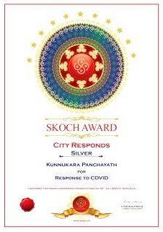

## **HEALTH CARE ACTIVITIES**

A comprehensive COVID-19 preventive programme was implemented in the Kunnukara panchayath down to the ward level. As part of the programme, following administrative measures has been taken in the panchayath. The preparations are part of the steps to prevent the possible community spread of COVID-19.

1. 24 hour control room in PHCs to coordinate health activities
2. Steering committee including opposition members meet regularly for quick decision making.
3. Organized ward level sanitation committee
4. Whatsapp group of 250 implementing team (Covid 19 rescue team) for effective coordination

## **BREAK THE CHAIN ACTIVITIES**

Kerala state government had launched a **'break the chain'** campaign to fend off the spread of Covid-19. State Health Minister Smt. K. K. Shailaja officially declared the 'break the chain' campaign to sensitise the public about the need for washing hands as keeping personal hygiene to prevent and break the further spread of the Novel corona virus, COVID -19. While efforts to contain the spread of COVID-19 were progressing efficiently, the Kerala government launched ‘**Break the Chain’**, a campaign that mainly involved a sanitation spree and lessons on social distancing. Water taps were installed at all public places along with bottles of hand package, benefiting all sections of the society. The Kerala government also launched a mobile application ‘**GoK Direct’** to ensure the public had access to the right information regarding monitoring symptoms, approaching health officials, selfcare and isolation etc. To enhance awareness and induce a behaviour change, a public health campaign ‘Break the Chain’ was launched to promote personal hygiene practices and social distancing. The campaign was largely successful in containing the spread of the virus.

Kunnukara panchayath too played crucial role in the control of Covid 19. In order to deal with COVID-19 pandemic, Kunnukara panchayath have initiated various steps, which include setting up of quarantine centers/camps, Isolation wards, sample collection centers and laboratories. Stringent measures were taken by the panchayath to ensure the safety of the residents. Apart from hand washing activities, wearing masks and using sanitizers in the offices and as well as in the public places were made mandatory even during the initial stage of corona hit.

**MEASURES TAKEN TO MITIGATE THE RISK**

1. **Public place disinfection-** In the wake of COVID-19 spread, team members of Covid 19 rescue team and local people has disinfected public places, hospitals and other facilities visited by patients.
2. **Hand washing facilities in public spaces- installed 50 facilities**
3. **Distribution of masks**
4. **Distributed immunity boosting traditional medicines to all houses**
5. **Psychological counselling to frontline workers**

## **3. COMMUNITY- BASED APPROACH**

### **3.1 KUNNUKARA CDS**

In addition to the Kudumbasree initiative started on May 17, 1998, the Community Development Society started its work in 2003 in Kunnukara grama panchayath. Initially there were 160 Kudumbasree units. Today, there are 3881 women working in 218 neighbourhood groups. WhatsApp groups have been set up at the CDS level and at all ADS levels and in all possible neighbourhoods to ensure timely delivery of various directives and notifications issued by the government as part of Covid disease control.

Kunnukara CDS actively took part in the COVID - 19 Activities that were carried out during the time of Lockdown period. On March 26th, 2020, the Community Kitchen was started by Kudumbashree with the help of Panchayat Authority. The on- ground surveillance systems were community-based involving elected representatives of local governments, members of the self-help group (SHG) called ‘Kudumbashree’ and the people who came forward and volunteered.

### **3.2 COMMUNITY KITCHENS**

The community kitchens were launched to provide food to those in need as part of the State government’s directive to ensure that nobody remained without food amid the lockdown. Those who are in home quarantine, those unable to cook because they stay alone in lodges or have no essentials, the elderly and the indigent, destitute people, bedridden patients, and those who seek alms will be provided food from the community kitchens. Kunnukara panchayat with four kitchens has the highest number of community kitchens in the Ernakulam district. 1) Cds members residence, N kuthiyathode, 2) Thanima bakers and canteen, N Aduvasserry 3) Kanthari kanjikkada, S Aduvasserry and 4) Green chilly food cafe, near panchayath, kunnukara. Community kitchens were set-up by the local governments with the support of ‘Kudumbashree’ to ensure cooked meals were readily available to the needy.

During the Lockdown period, food to the Asraya, Calling Bell and Elderly Neighbourhood Groups (NHG) members were supplied from Community Kitchen. The food packets were distributed to Guest Workers from different states and to Old aged people who were living alone. The Community Kitchen was working actively from March 26 th to April 24 th and thereafter the Kitchen was closed temporarily. During the time of Lockdown, a Cafe Corner was started by five member Group at Kochi International Airport as per the directions from District Collector Shri. Suhas, IAS.

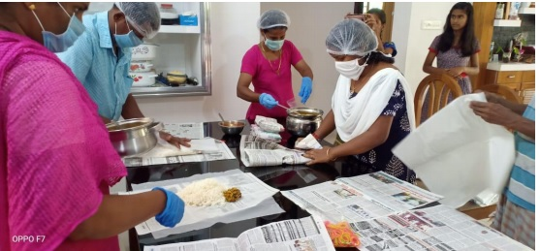

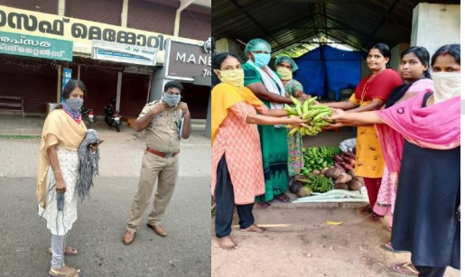

Apart from the Community Kitchen Activity, another important activity that was co-ordinated by panchayath during the COVID - 19 scenario was disinfection of infected areas with the help of **Harithakarmasena**. The Quarantine Center of Panchayat is cleaned by two Harithakarmasena members every day. The Harithakarmasena does their duty efficiently by observing the COVID protocol. Apart from disinfection activity, the 19 member Harithakarmasena collects plastics from all the 15 wards of the Panchayat even during the period of COVID - 19 and deposits in the Material Collection Facility (MCF) of Suchitwa Mission.

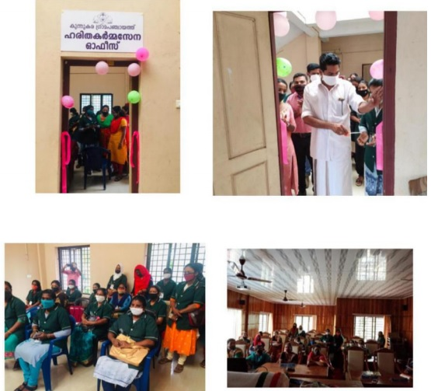

Face masks were stitched by the Garment Units and distributed with the help of different Government Departments. The vegetables and other food products were mobilized from Kudumbashree ME Units and Joint Liability Groups (JLGs).

## **MOBILE APPLICATION FOR KUNNUKARA GRAMA PANCHAYAT**

Kunnukara grama panchayat in Ernakulam district launched a mobile application to improve the reach of its various services to the people. Through this application, various facilities provided by the panchayath including food, volunteers, doctors, transport facilities, essential services and blood bank information can be easily delivered to the people. All the online services of the panchayath about Covid 19 are available through the app. People would be able to make suggestions and bring development issues, which need the urgent attention of the authorities through this application. The programme was developed by MES College, Kunnukara.

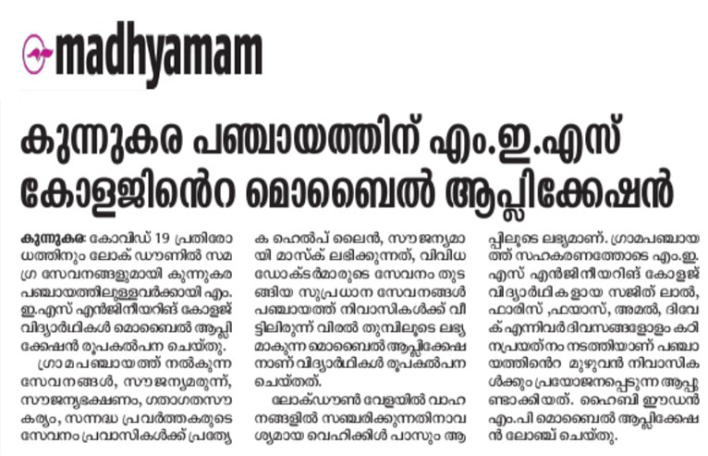

## **PREPARATION OF QUARANTINE FACILITIES**

To control the spread of Covid 19, putting suspected people under quarantine is the best option as no medicine till date has been invented to cure this pandemic. Home quarantine and in institutional quarantine are the 2 types of quarantine facilities arranged by the panchayath. Two types of facilities have been made available under institutional quarantine that is paid and free as demanded by individuals. Free institutional quarantine arranged in 21 anganwadis, one in lower primary school and one in pakalveedu. Paid institutional quarantine made as per individual demand. For home quarantine, strong support from panchayath made available in all time. During the event of flood, 1000beds in nearby municipalities were made with quarantine facilities. Provided 5359 free provision kits to migrant people, home quarantine people, school students etc.

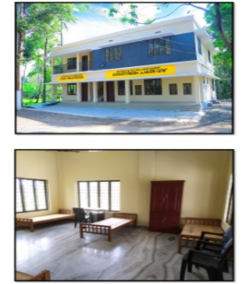

## **SUBHIKSHAKERALAM**

Subhikshakeralam is a unique concept to address the shortage of food, food grains, vegetables and fruits for which the state is currently depending on other states through the promotion of agricultural activities. Panchayath currently ensuring smooth supplies in the future by Subhikshakeralam Project using plan fund.

## **MANAGING MIGRANT WORKERS (GUEST LABOURS)**

Nowadays, migrant labours are one of the major threats to all local bodies because of unhygienic living conditions and lack of basic amenities to live in a healthy atmosphere. Due to the wide spread of corona and lock down the income of migrant labours were stopped and there were no transport facilities to return to their hometown. In Kunnukara panchayath there are 282 migrant labours who coming from various part of the country. They were going through mental stress as well. As a relief to migrant workers, panchayath distributed free food kits to needy family and arranged accommodation for them. Panchayath ensured healthy living condition in all migrant camps by providing medical services as regular manner. Panchayath made arrangements for registration to book return ticket for them.

<https://www.thehindu.com/news/cities/Kochi/community-kitchens-feed-the-needy-in-crisis-time/article31187785.ece>

<https://keralakaumudi.com/news/news.php?id=362082&u=local-news-ernakulam>

<https://exhibition.skoch.in/beacons-of-hope/kunnukara-panchayath/>