Case Study 1- COVID-19 Awareness Campaign
As Budhudih panchayat of Gandey block in Giridih district was severely affected by the covid pandemic during the second wave, a number of awareness campaign was run by the mukhiya Smt. Ruby Devi. This was due to:
- Migrants coming to the village from metro cities that lead to increased number of Covid cases
- The people were less attentive towards behaviour change to prevent the virus
- Lack of awareness about covid among the people
- The people did not obey the restrictions of going to many places
- The death of 2 people in the village made the villagers afraid of the virus
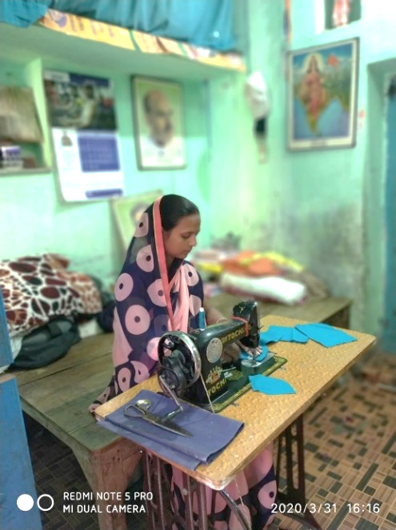
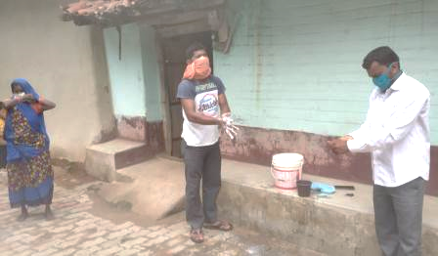
WV India contacted the mukhiya of Budhudih panchayat Smt. Ruby Devi and a volunteer Mr. Sandeep Verma to address these challenges immediately and to take necessary precautions during that time. Much work has been recognised in the form of virtual orientation given by WV India WASH team on what the virus was, seriousness of the covid situation, and CAB to about 20 volunteers who were identified and listed by the mukhiya who in turn sensitised about 1000 people in the village about the same. With their support, the mukhiya along with the AWC sevikas, jal sahiya and ward members organised programs in the entire panchayat to protect their people from the global corona virus. During these programs, the mukhiya visited household conveying messages on following government guideline and on behaviour change through demonstrating on hand wash, wear double layer mask, maintaining social distance and other ways to protect oneself from the virus. The WASH facilitators always provided a helping hand to the mukhiya while visiting households and made themselves available when she needed them.
Hand wash demonstration to community people

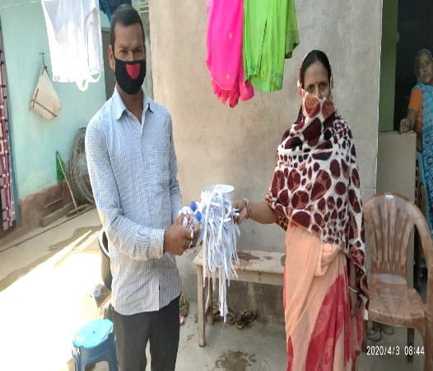
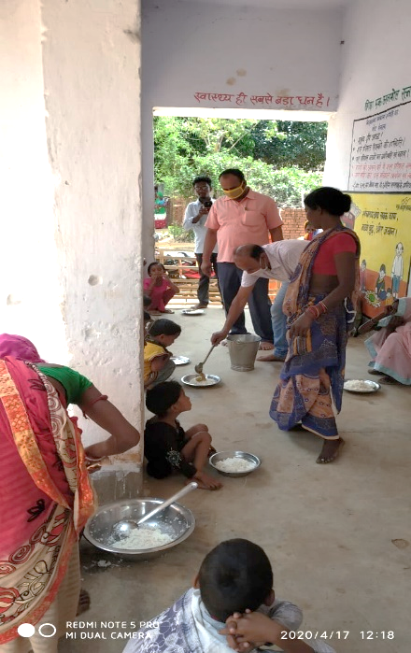
To ensure covid messages were easily spread among the community and to raise awareness among the masses, she initiated the formation of WhatsApp group. Information at the grassroots level were given to the people though these groups. About 500 people including the mukhiya, the PRI members of the panchayat, jalsahiya, all anganwadi workers, health workers, all teachers and all the dignitaries of the panchayat were members of these groups. Information such as what is covid, vaccination, covid test and other related issues were shared. Smt. Ruby Devi opined “jab bhi koi karyakram hota tha, WhatsApp ke madhyam se logon ko asane se jankare mil jati thi” (whenever there was any program, people got the information easily through whatsapp). Soaps, masks and sanitizers were also distributed to people at home though the mukhiya and she ensured the community people the supply of medicines in conjunction with MOIC and food free of cost. In various localities of the village, camps were formed by her with the help of health workers to vaccinate people and test them for covid. In these camps, instructions were given to the community people to wear double layer masks and to maintain distance of about 2 feet from one another whenever stepping out from home. “Camps banaya taki swasth suvidha mein bheer na ho” (formed camps, so that health facility do not get crowded) the mukhiya added. Budhudih School of the village was made into an isolation home to admit the migrants and the mukhiya provided funds for the supply of food and medicines to take care of people admitted there.
Smt. Ruby Devi making masks for the community
Mukhiya distributing masks to the community
The work done at the grassroots level by Smt. Ruby Devi was highly appreciated so much that this panchayat was given Deen Dayal Upadhyay Puraskar by Government of India as the best performing panchayat in the month of May 2021. Also, 25 hand pumps were fixed along with the approval of pension for the elderly, widow and people suffering from covid. In order to ensure that people do not have more difficulty in their daily life due to lockdown, work was done under MGNREGA programme so that people can lead their life in a normal way. Now, since last week no new positive cases from the village was reported and almost all people knew about the virus.
Food distribution to the community though mukhiya

Case Study 2- COVID Warriors
A group of covid warriors- Mr. Chittaranjan Mahato a community representative, mukhiya Mr. Phanibhushan Singh and Mr. Anand Mahato head master of a school worked in Sonahatu block of Ranchi district during covid, as there was:
- Increased rate of covid cases in Sonahatu block
- Hospitals in this block lacked adequate human resource, beds and oxygen to treat covid patients. In CHC Sonahatu, the number of beds was 24 which was insufficient for the treatment of covid patients.
- People did not follow the covid protocols
In such a grave situation, our WV India WASH staff stepped forward in helping the community to prevent the spread of covid. Though virtual training, they spread awareness among the health workers on the importance of wearing masks, maintaining social distance, self-quarantining and frequent use of hand sanitizers and soap. They as well made frequent contact with Mr. Chittaranjan Mahato a representative of the society who was the former member of Zilla Parishad of Dobadih village of block Sonhatu. He worked at the grassroots level to help those in need, he continued to serve the people without worrying about himself at the time of the pandemic. “Logon ki halat theek nahin thi, har jagah maine logon ko covid ke karan marte dekha”. (The condition of people was not good, everywhere I saw people dying due to covid) said he. He as well worked in collaboration with health workers of CHC Sonahatu to share information on covid to people visiting the hospitals. He as well as the ANM reached the community to generate awareness on the same and also motivated the people to wash hands frequently with soap and always wear a mask. “Yeh kaafi nahi hai, aur bhi logon ko madad ki zaroorat hai” (This is not enough, more people need help) Mr. Chittaranjan Mahato added.
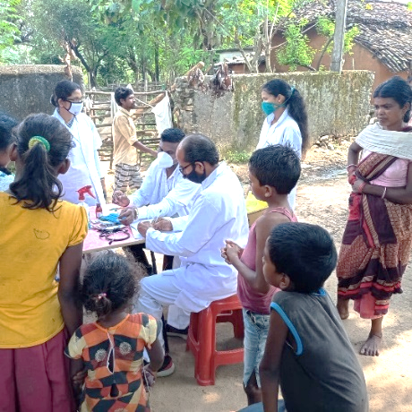
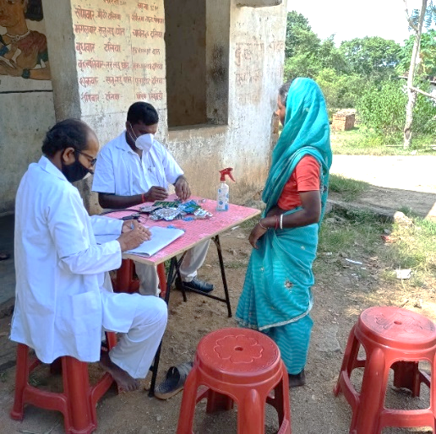
He realised that he cannot help people alone as the situation gotten worse every day and he did not know how to improve the conditions of hospitals to treat patients better. Hence in his work for betterment of the society and to prevent people from becoming covid victims, he was accompanied by the mukhiya Mr. Phanibhushan Singh of Munda Panchayat of Sonahatu block along with the head master of Om Shanti Vidya Mandir school Mr. Anand Mahato. “Mere school ke kuch bachche virus se prabhavit the aur unke mata pita ne mujhse madad mange the” (some of the children of my school were affected by the virus and their parents approached me for help) quoted the head master Mr. Anand Mahato. The first step undertaken by them was distributing masks and sanitizers to the community especially to those who could not afford. They reached the households of the under privileged to distribute essentials like food, medicines and masks. They covered most of the community people in Sonahatu block, but they wanted to reach other blocks as well. Hence they made connections with MLA Mr. Sudesh Mahato of Silli block.
Distribution of sanitizers and masks to community by covid warriors

In collaboration with Mr. Sudesh Mahato, they constantly distributed soap, masks and sanitizers to the people. Not only had that, they tried to reach the hospitals to provide beds, oxygens and other requirements for covid affected patients. Under the instructions of CHC Sonahatu, they cooperated with the ANM in distributing medicines to the households where covid patients were kept in isolation as well as in hospitals too.
Distributing medicine to community

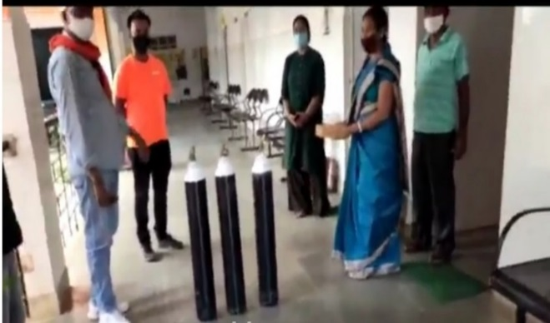
Salute to all the covid warriors whose constant support at the hospitals improved their conditions. The supply of covid equipment made people realise the importance of following protocols and decrease in the number of positive cases. Their work did not stop there, they continued with their social service in many hospitals as well. In collaboration with MLA Sudesh Mahato, they arranged for 5 beds in CHC Sonahatu, 20 in CHC Silli, and 5 in PHC Rahe along with oxygen supply. With WV India further planning was made to make Pandadih Subcenter of Sonahatu block a covid center with 3 beds oxygen, to deliver food to the needy people at home and to provide drugs and essentials to the covid patients kept in isolation at home with help of the MLA.
Supply of oxygen in CHC Sonahatu by Mr. Chittaranjan Mahato in collaboration with the MLA

Case Study 3- A Fight Against the Virus
Smt. Sunita Manki, the mukhiya of Berakenduda Panchayat in Anandpur block under West Singhbhum district fought against the virus as people were severely affected due to the spread of covid rampantly across the village:
- The virus affected the lives of many people in the community
- The virus caused a fear among the villagers
- Lack of precautions taken to avoid the virus
- Several misconceptions prevailed in the village in taking the vaccination, as people believed taking it would lead to death of people especially the elderly. Due to this, the villagers stayed away from participating in the vaccination program run by the government which resulted in only 10% of the villagers participating.
In this panchayat the female head Smt. Sunita Manki did a lot of responses against the covid pandemic and beyond. Similarly, currently district Swachh Bharat Mission’s team and WASH staff of WV India carried out awareness campaign on a virtual mode in view of the current situation of the covid pandemic, in which the mukhiya jalsahiya, ward members, village head, teachers and social leaders took part. It was through them which lead to the spread of information to the community. During these campaigns, each and every aspect of covid were discussed so that people were not afraid of the virus, people take precautions and most importantly change the mind-set of the villagers in taking vaccination.
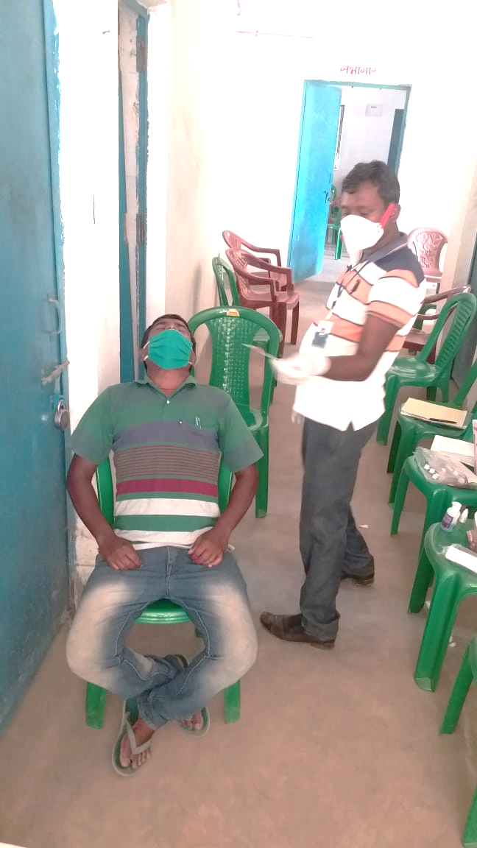
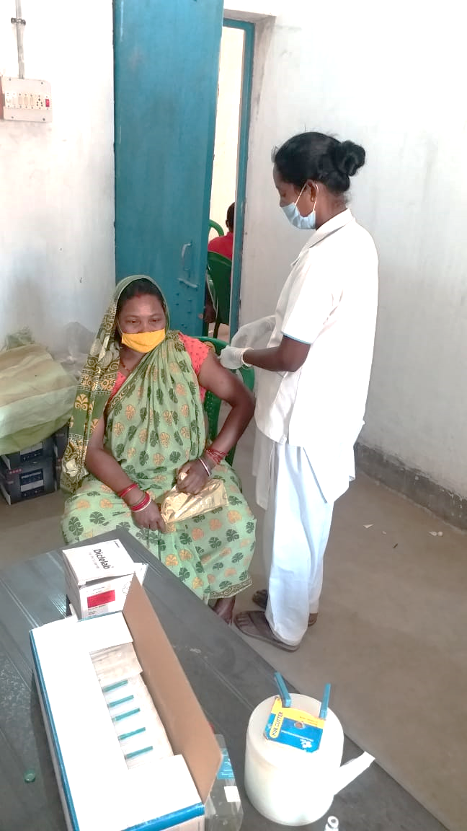
Smt. Sunita Manki geared up for improving the community. Most often she organised the awareness campaign with key personnel with a view that her active involvement will enable the people to listen to her and follow the government guideline. She made frequent visits in the village to ensure people followed the protocols, wore masks, instructed them to follow social distance when moving out of their homes, painting on walls regarding precautious measures during covid, as well as educating children and the elderly about the virus. This lead to most villagers using masks and following social distancing protocols. “Main jyada se jyada logon tak pahunchne ke lie jamene star se kaam karna chahati thi” (I wanted to work from the grassroots level to reach as many as possible) said the mukhiya. People who came to the village from outside got covid test done from the health center as instructed to them previously. Continuous sharing of information about the virus and vaccination removed the misconceptions among the people in the village that they previously had. They were also assured that taking vaccination would not harm the body, in fact it would strengthen the body to fight the virus. Though the mukhiya, people above 45 were motivated to participate in the vaccination program by availing the free vaccine to avoid danger from the virus. “Ab bahut se log government guideline ka palan karte hain jo pehle aisa nahin tha” (now many people follow the government guidelines which was not the case before) Smt. Sunita Manki concluded.
Covid testing by the community people
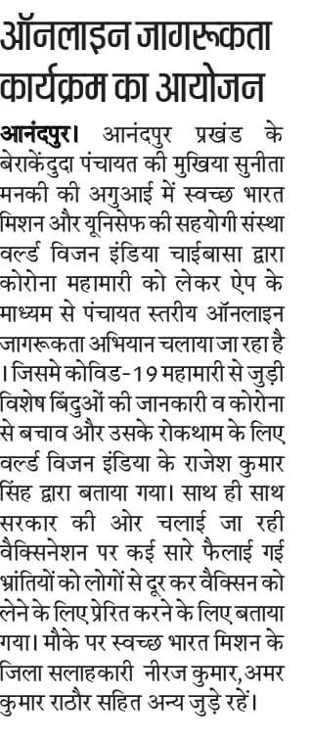
In this way panchayat level awareness campaign proved to be beneficial, in which the active participation of the mukhiya lead to the continuity of spread of information in the village and villagers were ready to fight the global pandemic.
Community people getting vaccinated
Media coverage Hindustan newspaper, 7th May, 2021

